Welcome!
This is a step-by-step guide to access the Chesapeake Classrooms and MELP SharePoint site.
Step 1: After you register for a summer institute, you will receive an e-mail from Microsoft Online Services Team (msonlineservicesteam@email.microsoftonline.com) to the email address you provided on the registration form.
Step 2: Click the orange text “Chesapeake Classrooms”. It is a link directly to the Chesapeake Classrooms and MELP SharePoint site. (If you have a Microsoft account make sure you are logged-in, and you should have automatic access to the Chesapeake Classrooms SharePoint page.)
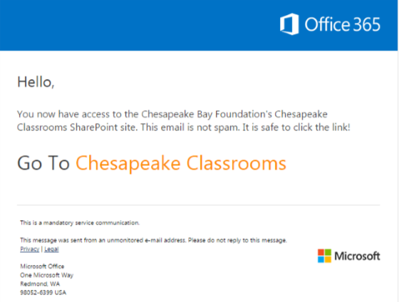

Step 3: If you do NOT have a Microsoft account, clicking the orange text will prompt you to create an account with a Microsoft service of your choice. Click your choice or “Create a Microsoft account” and follow the prompts. Once you’ve created an account, click the orange text again to get access to the site.
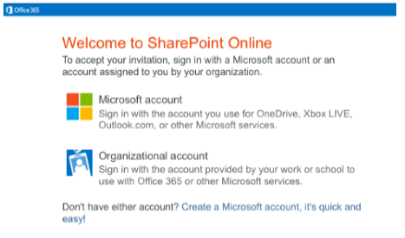

Step 4: When you arrive at the Chesapeake Classrooms homepage, you will see all of your course resources.

