Title | “Understanding Our Impact-Causes & Effects of Human Activities on Chesapeake Bay Oysters”
Audience (grade, course) | 6th grade Life Science

Curriculum Anchor
Learning Objectives and Curriculum Connection Curriculum Indictors, performance expectations, and/or learning objectives
MS-LS2-4. Construct an argument supported by empirical evidence that changes to physical or biological components of an ecosystem affect populations.

Driving Question(s) A broad, open-ended, life-relevant question that is based on the standards/learning objectives. Guides inquiry for the investigations, prompts the development of actionable claims.
- What are some negative/positive effects of human activities on Bay ecosystems and populations of oysters that live there?
- What roles do individuals and groups play in preserving and protecting oysters and their habitats?

Context Establishes local connections and life-relevance of the core ideas in the learning objective and driving question.
We will set the context, activate our prior knowege, and prepare for both the investigation and the civic engagement of this unit by exploring websites and online articles about oysters and their habitats.

Students will work in teams to explore the following articles and websites:
- The Bay Ecosystem (Chesapeake Bay Program)
- Eastern Oyster (Chesapeake Bay Program)- oyster basics and video clip on filtration
- Oysters & Oyster Reefs (NOAA) –
- Oyster Infographic (NOAA): 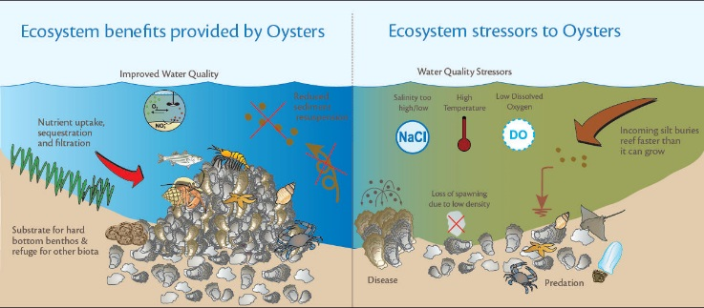
Students will be asked to answer the following questions as they explore the resources:
- What roles do oysters play in their environments?
- What are some of the different ways that graphic images, illustrations, pictures, and ‘infographics’ are used to comminicate information & ideas?

Issues Investigation:
What are some negative/positive effects of human activities on Bay ecosystems and populations of oysters that live there?

- Defining Issues and Asking Questions
Students will work in teams to generate investigative questions to help them make sense of the driving question.

Possible investigative questions:
- In what ways to ecosystems depend on oysters?
- What biotic and abiotic environmental factors affect the oyster’s ability to thrive?
- How do we assess the ‘health’ of the oyster’s environment? How do we measure and interpret relevant data?

These questions (and others that students might generate) are all interrelated and work together to make sense of the driving question and the learning objectives. Therefore, students will not be asked to choose one question, but rather work to understand them all.

- Planning and Conducting Investigations
Students will use their field journals to organize their investigations, record data, analyze data, and communicate conclusions. Each student’s field journal should include the following components for this investigation:
  - Investigative Questions:
  - Data Description: Description of data factors with an explanation for each about WHY that factor counts as data
  - Setting: Description of location for data collection with an explanation for WHY that location may be an acceptable source of data
  - Section for Field Notes: Notes taken in the field about methods of data collection, conditions, etc.
  - Data collection charts (student teams decide best method for organizing the data in charts)
  - Data Analysis: Written explanation about what the data indicates
  - Conclusion section (see below)

- Field-Based Experience: students will explore a local waterway (either a local stream, river, or part of the Bay) to make observations and collect data about factors that affect water health. These factors may include biodiversity, dissolved oxygen levels, temperature, Ph, nitrogen and phosphorous. In discussions before and after the field experience, students will discuss why these (and other) indicators might be used as data to help us in our investigations.
- Students will use water quality testing equipment including DO meters, seine nets, phosphorous meters, turbidity tests, etc.
- Students will have access to “experts” from NOAA fisheries (through email correspondence or a scheduled class visit from individuals-teacher will set this up ahead of time) for assistance and/or insight in analyzing and interpreting their data.
- Analyzing and Interpreting Data
- Students will use field journals to collect and analyze information related to the investigations. For each component, the class will discuss together what will be considered adequate completion. For example, the students will talk as a group with the teacher about what a “good” Data Description section will look like. The teacher will also share her grading/assessment protocol.
- Students will use technology (PowerPoint, etc) to develop interactive presentations to share their findings with the class.
- Constructing, Communicating, and Refining Explanations:
  - Students will work in teams to develop a response to the following prompt (based on driving question 1):
What are some negative/positive effects of human activities on Bay ecosystems and populations of oysters that live there? Use evidence collected in your investigations to support your answer.
  - Teams will share their conclusions with other teams for feedback and will have an opportunity to ‘upgrade’ their conclusions if needed.

Civic Engagement:
What roles do individuals and groups play in preserving and protecting oysters and their habitats?
The civic engagement portion of this unit will focus on building public awareness about the ways that human activities negatively impact oysters and their ecosystems.

- Developing Claims:
  - Students will work in teams to develop a claim to address the following problem/prompt:
Human activity continues to negatively affect populations of oysters in the Bay. The Public needs to be more aware of h based on the causes and effects of human activities on populations of Oysters in the Chesapeake Bay. What roles do individuals and groups play in preserving and protecting oysters and their habitats? What is the most effective way to communicate this information to public audiences in order to inspire behavior change?

- Designing Solutions and Implementing Action
  - Teams will create a written response to the above prompt. They will collaborate to create a “Public Service Announcement” to communicate particular points of information to particular audiences. Each team will determine which information is most appropriate/relevant for their team to communicate.
  - Teams will determine a medium for communicating this information. Media might include infographics (created with free online software programs), charts, graphs, videos, audio recordings, etc.
Note: The choice of media will also depend on resources available. The teacher may decide that all teams will create one particular type of PSA-for example, all teams will create an infographic.
  - An audience for the PSA will be chosen either by the teacher or by the group. Possible venues/audiences might include the school or community newsletter, local newspaper, city hall, etc.
- Evaluating Action
  - As a group, the class will determine criteria for successful PSAs. Criteria may include: accuracy of factual information, clarity, aesthetics, etc.
  - The teacher will assess each PSA according to her own grading criteria (Which should be shared with the students)

